GRUPO ESCOLAR MUNICIPAL MONTEIRO LOBATO

ATIVIDADES COMPLEMENTARES

7º ANO

PROFESSOR(A): GENOEVA MACULAN (Geografia)
GILBERTO BET (Informática e Ensino Religioso)
MARCOS MARMENTINI (Artes)
CARLOS ALEXANDRE PICCHI (Educação Física)
RAQUEL ADRIANA SOUZA (Inglês, Português)
ELIZANGELA BIAZIN (Ciências)
CRESCELIA A. OLIVEIRA (História)
PAULA ZORZI (Matemática)

Coronel Martins, 27 de abril de 2020

GRUPO ESCOLAR MUNICIPAL MONTEIRO LOBATO
PROFESSORA: RAQUEL ADRIANA SOUZA DATA: ____/____/____
ALUNO(A): __________________________________________________________________
LÍNGUA INGLESA – 7º ANO
ATIVIDADE: Na página 14, você deverá fazer as atividades número 10,11 e 12 – Let’s discuss. Você deverá copiar a pergunta e formular a resposta:
10-_________________________________________________________________________________________________________________________________________________________________________________________________________________________________________________________________________________________________________________________________________________________________________________________________________________________________________________________________________________________________________________________________________________________________________

11-________________________________________________________________________________________________________________________________________________________________________________________________________________________________________________________________________________________________________________________________________________________________________________________________________________________________________________________________________________________________________________________________________________________________________________________________________________________________________________________
12-
__________________________________________________________________________________________________________________________________________________________________________________________________________________________________________________________________________________________________________________________________________________________________________________________________________________________________________________________________________________________

GRUPO ESCOLAR MUNICIPAL MONTEIRO LOBATO
PROFESSORA: RAQUEL ADRIANA SOUZA DATA: ____/____/____
ALUNO(A): __________________________________________________________________
LÍNGUA INGLESA – 7º ANO
ATIVIDADE: Responder as seguintes questões referente ao assunto da unidade 1:
- Quais são os aspectos positivos de “crescer”?
______________________________________________________________________________________________________________________________________________________________________________________________________________________________________________________
- Escolher seus próprios padrões e levar algum tempo para se conhecer faz parte do processo de crescimento. O que mais pode ser considerado como parte desse processo?
______________________________________________________________________________________________________________________________________________________________________________________________________________________________________________________
- Qual é a importância de apreciar mais as forças internas do que a aparência?
______________________________________________________________________________________________________________________________________________________________________________________________________________________________________________________
- Você acredita que a felicidade depende de um estágio específico da vida? Por quê?
______________________________________________________________________________________________________________________________________________________________________________________________________________________________________________________
- Você acha que a família e os amigos são importantes durante os diferentes estágios da vida? Por quê?
______________________________________________________________________________________________________________________________________________________________________________________________________________________________________________________

GRUPO ESCOLAR MUNICIPAL MONTEIRO LOBATO
PROFESSORA: RAQUEL ADRIANA SOUZA DATA: ____/____/____
ALUNO(A): __________________________________________________________________
LÍNGUA INGLESA – 7º ANO
ATIVIDADE: Produza um texto baseado nas suas respostas da atividade anterior e de acordo com a sua percepção sobre essa fase tão significativa da vida das pessoas e se você tiver acesso a um dicionário de inglês ou internet, passe esse texto para o Inglês. Elabore um título bem criativo:

__________________________________________________________
________________________________________________________________________________________________________________________________________________________________________________________________________________________________________________________________________________________________________________________________________________________________________________________________________________________________________________________________________________________________________________________________________________________________________________________________________________________________________________________________________________________________________________________________________________________________________________________________________________________________________________________________________________________________________________________________________________________________________________________________________________________________________________________________________________________________________________________________________________________________________________________________________________________________________________________________________________________________________________________________________________________________________________________________________________________________________________________________________________________________________________________________________________________________________________________________________________________________________________________________________________________________________________________________________________________________________________________________________________________________________________________________________________________________________________________________________________________________________________________________________________________________________________________________________________________________________________________________________________________________________________________________________________________________________________________________________________________________________________________________________________________________________________________________________________________________________________________________________________________________________________________________________________________________________________

GRUPO ESCOLAR MUNICIPAL MONTEIRO LOBATO
PROFESSORA: RAQUEL ADRIANA SOUZA DATA: ____/____/____
ALUNO(A): __________________________________________________________________
LÍNGUA INGLESA – 7º ANO
ATIVIDADE: Copiar e responder as questões número 7 e 8 da página 24 – Let’s discuss:

7-
______________________________________________________________________________________________________________________________________________________________________________________________________________________________________________________________________________________________________________________________________________________________________________________________________________________________________________________________________________________________________________________________________________________________________________________________

8-
__________________________________________________________________________________________________________________________________________________________________________________________________________________________________________________________________________________________________________________________________________________________________________________________________________________________________________________________________________________________________________________________________________________________________________________________________________________________________________________________________________________________________________________________________________________________________

GRUPO ESCOLAR MUNICIPAL MONTEIRO LOBATO
PROFESSORA: RAQUEL ADRIANA SOUZA DATA: ____/____/____
ALUNO(A): __________________________________________________________________
LÍNGUA PORTUGUESA – 7º ANO
ATIVIDADE: Ler e observar com atenção a charge da página 35 – Aplicando conhecimentos – e copiar e responder as questões A, B, C, D e E. (OBS: Se tiver alguma dúvida para responder as questões C, D e E, leia com atenção o quadro laranja que está logo acima da charge).

- ______________________________________________________________________________________________________________________________________________________________________________________________________________________________________________________________________________________________________________________________________________________________________________________________________________________________________________________

- _____________________________________________________________________________________________________________________________________________________________________________________________________________________________________________________________________________________________________________________________________________________________________________

- _____________________________________________________________________________________________________________________________________________________________________________________________________________________________________________________________________________________________________________________________________________________________________________

- _____________________________________________________________________________________________________________________________________________________________________________________________________________________________________________________________________________________________________________________________________________________________________________

- _____________________________________________________________________________________________________________________________________________________________________________________________________________________________________________________________________________________________________________________________________________________________________________
GRUPO ESCOLAR MUNICIPAL MONTEIRO LOBATO
PROFESSORA: RAQUEL ADRIANA SOUZA DATA: ____/____/____
ALUNO(A): __________________________________________________________________
LÍNGUA PORTUGUESA – 7º ANO
ATIVIDADE: Página 35 – Prática de leitura – Copiar e responder as questões 1 e 2 da página 35, ler o texto mensagens instantâneas por aplicativo e fazer as atividades – Por dentro do texto – das páginas 36, 37 e 38, número 1, 2, 3, 4, 5, 6, 7 e 8:
p.35:
1- ________________________________________________________________________________________________________________________________________________________________________________________________________________________________________________________________________________________________________________________________________________________________________________________________________________________________________________________________________________________________
2- ________________________________________________________________________________________________________________________________________________________________________________________________________________________________________________________________________________________________________________________________________________________________________________________________________________________________________________________________________________________________
p. 36, 37 e 38:
1- ________________________________________________________________________________________________________________________________________________________________________________________________________________________________________________________________________________________________________________________________________________________________________________________________________________________________________________________________________________________________

2-________________________________________________________________________________________________________________________________________________________________________________________________________________________________________________________________________________________________________________________________________________________________________________________________________________________________________________________________________________________________
3- ________________________________________________________________________________________________________________________________________________________________________________________________________________________________________________________________________________________________________________________________________________________________________________________________________________________________________________________________________________________________
4-________________________________________________________________________________________________________________________________________________________________________________________________________________________________________________________________________________________________________________________________________________________________________________________________________________________________________________________________________________________________
5-________________________________________________________________________________________________________________________________________________________________________________________________________________________________________________________________________________________________________________________________________________________________________________________________________________________________________________________________________________________________
6-________________________________________________________________________________________________________________________________________________________________________________________________________________________________________________________________________________________________________________________________________________________________________________________________________________________________________________________________________________________________
7-________________________________________________________________________________________________________________________________________________________________________________________________________________________________________________________________________________________________________________________________________________________________________________________________________________________________________________________________________________________________
8-________________________________________________________________________________________________________________________________________________________________________________________________________________________________________________________________________________________________________________________________________________________________________________________________________________________________________________________________________________________________
GRUPO ESCOLAR MUNICIPAL MONTEIRO LOBATO
PROFESSORA: RAQUEL ADRIANA SOUZA DATA: ____/____/____
ALUNO(A): __________________________________________________________________

LÍNGUA PORTUGUESA – 7º ANOATIVIDADE: Página 38 e 39 – Produção de texto – Mensagens instantâneas (ler o diálogo, copiar e responder as atividades número 1, 2, 3, 4, 5 e 6). OBS: Ler a questão número 7, pensar e escrever sugestões para realizarmos a atividade:

p.38 e 39:
1- ________________________________________________________________________________________________________________________________________________________________________________________________________________________________________________________________________________________________________________________________________________________________________________________________________________________________________________________________________________________________

2-________________________________________________________________________________________________________________________________________________________________________________________________________________________________________________________________________________________________________________________________________________________________________________________________________________________________________________________________________________________________

3-________________________________________________________________________________________________________________________________________________________________________________________________________________________________________________________________________________________________________________________________________________________________________________________________________________________________________________________________________________________________

4-________________________________________________________________________________________________________________________________________________________________________________________________________________________________________________________________________________________________________________________________________________________________________________________________________________________________________________________________________________________________
5-________________________________________________________________________________________________________________________________________________________________________________________________________________________________________________________________________________________________________________________________________________________________________________________________________________________________________________________________________________________________

6-________________________________________________________________________________________________________________________________________________________________________________________________________________________________________________________________________________________________________________________________________________________________________________________________________________________________________________________________________________________________

7-________________________________________________________________________________________________________________________________________________________________________________________________________________________________________________________________________________________________________________________________________________________________________________________________________________________________________________________________________________________________

NOME DA ESCOLA:
Componente Curricular: Ciências Turma: 7º Ano Professora: Elizangela Turmina Biazin

ALUNO: DATA:

Olá pessoal tudo bem com vocês, esperamos que estejam bem, a Prof. está bem, porém com saudades de todos vocês, de podermos conversar, de nossas aulas, de aprendermos juntos. Então gostaria que vocês escrevessem formassem 09 frases e, montassem um desenho representando o que cada um de vocês está ouvindo, vendo, sentindo, fazendo neste período que estamos sem aula.
ÓTIMOS ESTUDOS!
TEMA: Questionário e desenho de interação quarentena.

AQUI ESCREVA SUAS FRASES COM OS TEMAS SUGERIDOS:

- Como você está

.
- Como está sua família

.
- Como você está se sentindo

.
- O que você está fazendo neste tempo que está em casa

.
- Está com saudade da escola

.
- O que você mais gosta de fazer

.
- De que você está brincando

.
- O que você pensa sobre o corona vírus

.
- Algo que você gostaria de dizer
.

NOME DA ESCOLA:
Componente Curricular: Ciências Turma: 7º Ano Professora: Elizangela Turmina Biazin

ALUNO: DATA:

AQUI FAÇA UM DESENHO REPRESENTANDO VOCÊ E SUA FAMILIA, COMO VOCES, VENDO, OUVINDO SENTINDO E FAZENDO NESTE PERÍODO QUE ESTAMOS EM CASA.

NOME DA ESCOLA:
Componente Curricular: Ciências Turma: 7º Ano Professora: Elizangela Turmina Biazin

ALUNO: DATA:

TEMA: Camadas da atmosfera terrestre.

Ler com atenção as paginas 34 e 35 e em seguida resolver as atividades.
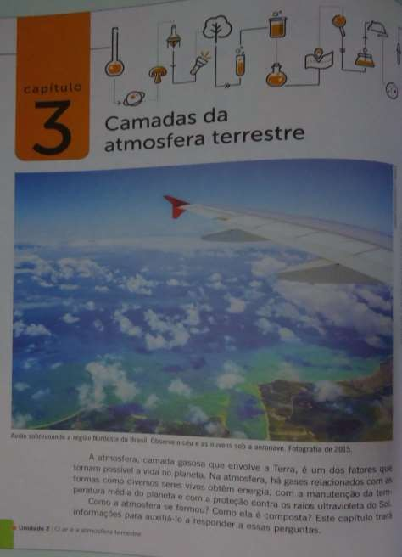
Pg 34.

Pg 35.
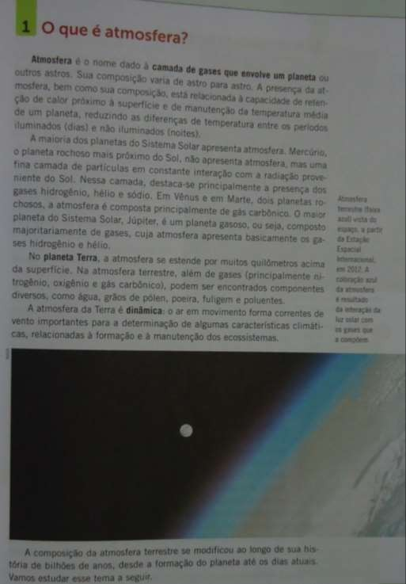

Responder as atividades referente as paginas 34 e 35:

  - O que é atmosfera ?

.

  - Haveria água na terra sem a presença da atmosfera ? Haveria vida ?.
.

  - Observe a imagem que mostra na página 35 atmosfera da terra como é vista da estação espacial internacional. Porque a atmosfera é azul ?

.

  - Complete: A maioria dos planetas do sistema solar apresenta .
, o planeta mais próximo do , não apresenta atmosfera, mas uma fina camada de particulas em constante
interação com a proveniente do . Nessa camada,
destaca-se principalmente a presença dos gases , hélio e
.
A seguir leia com muita atenção as páginas a seguir e após responder as atividades propostas.

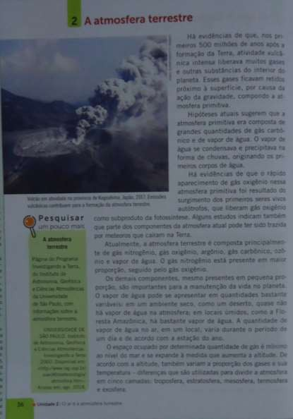
Pg 36
1. Observe a imagem acima. A quantidade de gazes expelidos pelo vulcão em erupção e imagine a terra com sua superfície coberta de vulcões quando ela se formou. O que você está vendo nesta imagem?

.

Ainda sobre a página 36. Veja, o gás oxigênio gera energia na reação de oxidaçãoda glicose na respiração celular; o gás nitrogenio é fixado pelas bactérias fixadoras de nitrogênio das raízes das leguminosas e entra na composição das proteínas. O gás carbônico é absorvido pelas plantas na fotossíntese; O gás carbônico e o metano formam uma camada de gases que
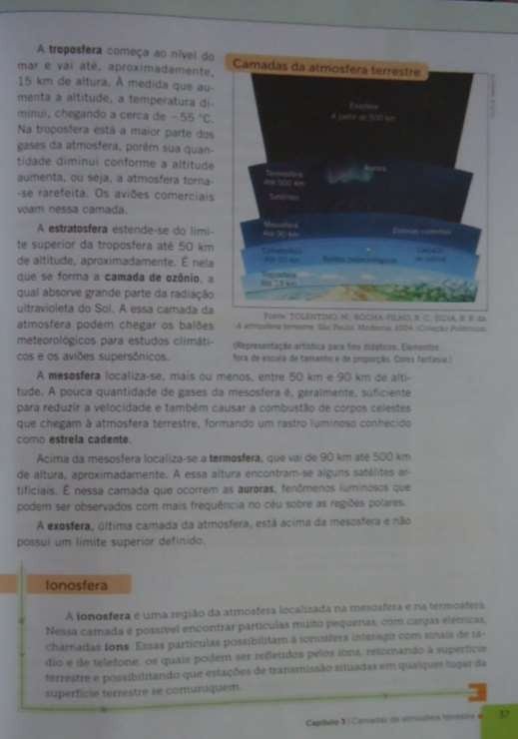

NOME DA ESCOLA:
Componente Curricular: Ciências Turma: 7º Ano Professora: Elizangela Turmina Biazin

ALUNO: DATA:

Continuando nossos estudos, leias as páginas a seguir e resolva as atividades indicadas sobre o conteúdo a ser estudado.

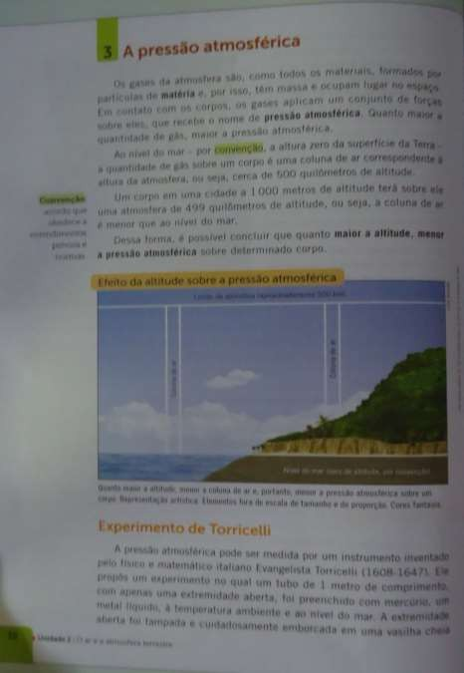
Pg 38.

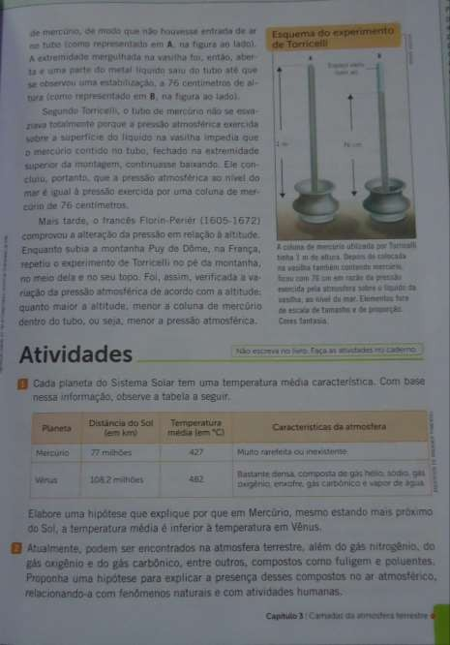
Escreva com suas palavras o que você entendeu sobre a pressão atmosférica:

.

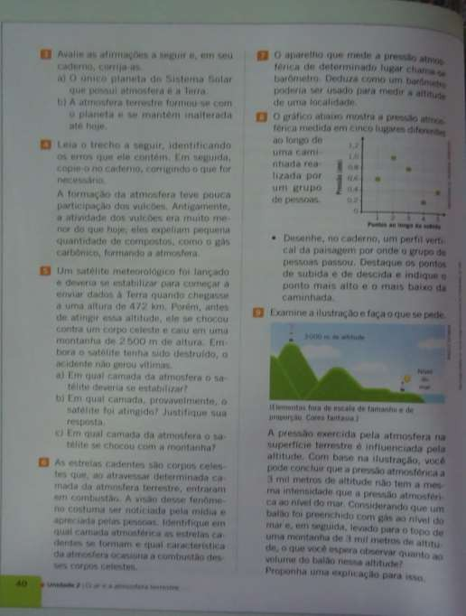

Responda as atividades 1 e 2 da página 39 e as atividades 3, 4, 5 e 6. Da página
40.

GRUPO ESCOLAR MUNICIPAL MONTEIRO LOBATO.
CORONEL MARTINS, _____________ ABRIL DE 2020.
PROFESSORA: GENOEVA LURDES MACULAN
ALUNO: ______________________________________________________
TURMA:7º ANO
DISCIPLINA: GEOGRAFIA

Atividades referentes as aulas não presenciais, para a disciplina de geografia.
- Com aproximadamente 8.511.945 Km2, o território brasileiro se destaca pelas proporções continentais, pela diversidade de paisagens climáticas, botânicas e pelo dinamismo econômico, entre outros fatores.
Sobre as características do território brasileiro, julgue os itens em (C) certo ou (E) errado:
- ( ) Brasil possui um território descontinuo, sendo o 5º maior país do mundo em terras descontínuas, ou seja, terras agregadas, superando neste aspecto os Estados Unidos.
b. ( ) Brasil faz fronteira com todos os países da América do Sul, com exceção do Chile e do Equador.
c. ( ) Possui a maior parte do seu território no hemisfério meridional e encontra-se completamente inserido no hemisfério ocidental, a oeste de Greenwich.
d. ( ) Possui dentre as características do seu litoral grande quantidade de recortes litorâneos e pequena exploração petrolífera oceânica.

- O território brasileiro se encontra localizado totalmente no hemisfério ocidental e sua maior parte no hemisfério meridional, com uma extensão territorial de 8.511.996 km2 , sendo um país tropical porque a maior parte de sua área territorial contínua se estende do Equador ao:
a. ( ) Trópico de Capricórnio.
b. ( ) Círculo Polar Ártico.
c. ( ) Trópico de Câncer.
d. ( ) Círculo Polar Antártico.
- Com relação à localização do Brasil, assinale a alternativa correta:
a. ( ) Está situada na América do Sul, em sua porção ocidental, banhado a leste pelo oceano Pacífico.
b. ( ) Está situado na América do Sul, totalmente no Hemisfério ocidental.
c. ( ) O Brasil é cortado ao norte pelo trópico de Capricórnio e ao sul pelo Equador.
d. ( ) Está situado totalmente no Hemisfério sul, portanto na zona de iluminação tropical.
- Tendo em vista a sua localização geográfica, o Brasil se apresenta como um país de clima tropical. Com base na tropicalidade brasileira, julgue os itens em (C) certo ou (E) errado:
a. ( ) O clima tropical do Brasil é consequência da sua localização em baixa latitude, ou seja, localizado entre os trópicos.
b. ( ) Todos os climas existentes no Brasil são controladas por massas de ar quentes e úmidas (equatoriais e tropicais).
c. ( ) O clima mais comum no Brasil é o clima tropical. Este, porém sofre algumas alterações como: tropical semi-árido, tropical de altitude, além da presença do clima litorâneo úmido, do equatorial úmido e do subtropical.
d. ( ) Do ponto de vista da produção agrícola, a diversidade climática nos é vantajosa, pois assim o Brasil conta com uma grande variedade de produtos agrícolas.
- Sobre a situação geográfica, quanto às zonas de iluminação, o Brasil tem 93% de suas terras na faixa tropical e apenas 7% na zona temperada do sul. É atravessado no norte pela linha do Equador e no sul, pelo:
a. ( ) Trópico de Câncer
b. ( ) Trópico Zonal
c. ( ) Trópico de Capricórnio
d. ( ) Polar Sul
- O Brasil ocupa uma posição territorial privilegiada, tanto no aspecto de localização quanto de dimensão. Com base nisso, julgue os itens em (C) certo ou (E) errado:
a. ( ) O Brasil, no aspecto de terras descontínuas, ocupa a quinta posição em maior extensão territorial
b. ( ) O Brasil se localiza totalmente no hemisfério sul quanto no hemisfério ocidental.
c. ( ) Quase 50% de todo o território do continente sul - americano pertence ao Brasil.
d. ( ) O Brasil localiza-se geograficamente no continente americano, sendo banhado por dois oceanos: o Atlântico a leste e o Pacífico, a oeste.

- Observe o mapa a seguir:
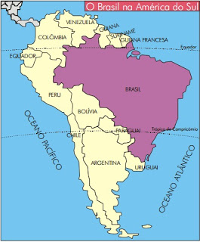
Com base na localização geográfica do Brasil, assinale a alternativa correta:
a. ( ) Está totalmente localizado nos hemisférios sul e oeste.
b. ( ) Parte de seu território está localizado no hemisfério sul e totalmente no hemisfério leste.
c. ( ) Está localizado no hemisfério sul ou meridional e no hemisfério oeste ou ocidental.
d. ( ) Por ser atravessado pelo meridiano de Greenwich, o território brasileiro apresenta-se inserido na zona tropical.
- Com relação à localização do Brasil, assinale a alternativa correta:
a. ( ) Está situado na América do Sul, em sua porção ocidental, banhado a leste pelo oceano Pacífico.
b. ( ) Está situado na América do Sul, totalmente no Hemisfério ocidental.
c. ( ) O Brasil é cortado ao norte pelo trópico de Capricórnio e ao sul pelo Equador.
d. ( ) Está situado totalmente no Hemisfério sul, portanto na zona de iluminação tropical.
Observação: para responder as atividades tem os textos do livro da página 12 até a 27; conteúdos que já estudamos e lemos em sala com explicação e atividades.

GRUPO ESCOLAR MUNICIPAL MONTEIRO LOBATO.
CORONEL MARTINS, _____________ ABRIL DE 2020.
PROFESSORA: GENOEVA LURDES MACULAN
ALUNO: ______________________________________________________
TURMA:7º ANO
DISCIPLINA: GEOGRAFIA

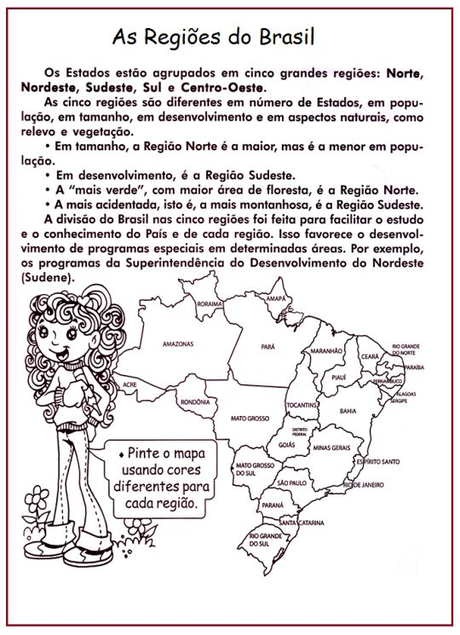
Bom trabalho!

GRUPO ESCOLAR MUNICIPAL MOTEIRO LOBATO
NOME DO ALUNO (A):
TURMA: 7º ANO
DATA:
EDUCAÇÃO FÍSICA – 2020
OBS: É de grande importância todos os dias fazer alongamentos. Peço a vocês que façam todos os dias no período da manhã e da tarde 10 alongamentos (10 cada período) que eram feitos nas aulas de Educação Física, cada alongamento tem que ter duração de 10 segundos cada.
VOLEIBOL (VÔLEI)

INTRODUÇÃO
Voleibol é um desporto praticado numa quadra dividida em duas partes por uma rede, possuindo duas equipes de seis jogadores em cada lado. O objetivo da modalidade é fazer passar a bola sobre a rede de modo a que a bola toque no chão dentro da quadra adversária, ao mesmo tempo que se evita que os adversários consigam fazer o mesmo. O voleibol é um desporto olímpico, regulado FEDERAÇÃO INTERNACIONAL DE VOLEIBOL (FIVB).
HISTÓRIA
O vôlei foi criado em 9 de fevereiro de 1895 por William George Morgan nos estados Unidos . O objetivo de Morgan, era criar um esporte de equipes sem contato físico entre os adversários, de modo a minimizar os riscos de lesões.
Em 1947, foi fundada a federação internacional de voleibol (FIVB). Dois anos mais tarde foi realizado o primeiro campeonato mundial de voleibol. Na ocasião, só houve o evento masculino. Em 1952, o evento foi estendido também ao voleibol feminino. No ano de 1964, o voleibol passou a fazer parte do programa dos Jogos Olímpicos , tendo-se mantido até a atualidade.
REGRAS
Cada equipe de voleibol é constituída por 12 jogadores: seis efetivos (sendo um Libero) e seis suplentes. Em quadra, portanto, ficam dois times de seis jogadores.
As equipes são separadas por uma rede no meio da quadra. O jogo começa com um dos times que devem sacar. Logo depois do saque, a bola deve ultrapassar a rede e seguir ao campo do adversário onde os jogadores tentam evitar que a bola entre no seu campo usando qualquer parte do corpo. O jogador pode rebater a bola para que ela passe para o campo adversário sendo permitidos dar três toques na bola antes que ela passe, sempre alternando os jogadores que dão os toques(UM JOGADOR NÃO PODE DAR DOIS TOQUES SEGUIDOS NA BOLA). Caso a bola caia, é ponto do time adversário.
O jogador não pode encostar na rede e, caso isso ocorra, o ponto será para o outro time. O mesmo jogador não pode dar 2 ou mais toques seguidos na bola, exceção no caso do toque de Bloqueio.

O CAMPO
É retangular, com a dimensão de 18 x 9 metros, com uma rede no meio colocada a uma altura variável, conforme o sexo e a categoria dos jogadores (exemplo dos seniores e juniores: masculino 2,43 metros e feminino 2,24 metros).
Há uma linha de 3 metros em direção do campo para a rede, dos dois lados e uma distância de 6 metros até o fim da quadra. Fazendo uma quadra de extensão de 18 metros de ponta a ponta(COMPRIMENTO) e 9 metros de lado a lado(LARGURA).
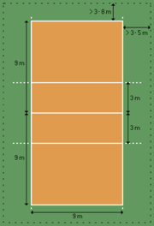
Campo de Voleibol.

ESTRUTURA
O voleibol é jogado por pontos, e não por tempo. Cada partida é dividida em sets que terminam quando uma das duas equipes conquista 25 pontos. Deve haver também uma diferença de no mínimo dois pontos com relação ao placar do adversário - caso contrário, a disputa prossegue até que tal diferença seja atingida. O vencedor será aquele que conquistar primeiramente três sets.
Como o jogo termina quando um time completa três sets vencidos, cada partida de voleibol dura no máximo cinco sets. Se isto ocorrer, o último recebe o nome de tie-break e termina quando um dos times atinge a marca de 15, e não 25 pontos. Como no caso dos demais, também é necessária uma diferença de dois pontos com relação ao placar do adversário.

ATIVIDADES SOBRE O VOLEIBOL:

1 - Em que ano foi criado o voleibol?
R:
2 - Qual a dimensão da quadra de voleibol?
R:
3 – Quem foi que criou o voleibol?
R:
4 – Uma partida de voleibol dura no Máximo quantos sets:
( ) 3 sets ( ) 4 sets ( ) 5 sets

5 - O voleibol é jogado por: ( ) Pontos ou ( ) Tempo.

GRUPO ESCOLAR MUNICIPAL MOTEIRO LOBATO
NOME DO ALUNO (A):
TURMA: 7º ANO
DATA:
EDUCAÇÃO FÍSICA – 2020

CONTINUAÇÃO DA AULA DO DIA 06/05/2020 SOBRE O VOLEIBOL

OBS: É de grande importância todos os dias fazer alongamentos. Peço a vocês que façam todos os dias no período da manhã e da tarde 10 alongamentos (10 cada período) que eram feitos nas aulas de Educação Física, cada alongamento tem que ter duração de 10 segundos cada.

O Jogo
No início de cada set, o jogador que ocupa a posição 1 realiza o saque, e, acerta a bola com a mão tencionando fazê-la atravessar o espaço aéreo delimitado pelas duas antenas e aterrissar na quadra adversária. Os oponentes devem então fazer a bola retornar tocando-a no máximo três vezes, e evitando que o mesmo jogador toque-a por duas vezes consecutivas.
O primeiro contato com a bola após o saque é denominado recepção ou passe, e seu objetivo primordial é evitar que ela atinja uma área válida do campo. Segue-se então usualmente o levantamento, que procura colocar a bola no ar de modo a permitir que um terceiro jogador realize o ataque, ou seja, acerte-a de forma a fazê-la aterrissar na quadra adversária, conquistando deste modo o ponto.
No momento em que o time adversário vai atacar, os jogadores que ocupam as posições 2, 3 e 4 podem saltar e estender os braços, numa tentativa de impedir ou dificultar a passagem da bola por sobre a rede.
Este movimento é denominado bloqueio, e não é permitido para os outros três atletas que compõem o restante da equipe.
Em termos técnicos, os jogadores que ocupam as posições 1, 6 e 5 só podem acertar a bola acima da altura da rede em direção à quadra adversária se estiverem no "fundo" de sua própria quadra. Por esta razão, não só o bloqueio torna-se impossível, como restrições adicionais se aplicam ao ataque. Para atacar do fundo, o atleta deve saltar sem tocar com os pés na linha de três metros ou na área por ela delimitada; o contato posterior com a bola, contudo, pode ocorrer no espaço aéreo frontal.
Após o ataque adversário, o time procura interceptar a trajetória da bola com os braços ou com outras partes do corpo para evitar que ela aterrisse na quadra. Se obtém sucesso, diz-se que foi feita uma defesa, e seguem-se novos levantamento e ataque. O jogo continua até que uma das equipes cometa um erro ou consiga fazer a bola tocar o campo do lado oponente.
Se o time que conquistou o ponto não foi o mesmo que havia sacado, os jogadores devem deslocar-se em sentido horário, passando a ocupar a próxima posição de número inferior à sua na quadra (ou a posição 3, no caso do atleta que ocupava a posição 4). Este movimento é denominado rodízio.
As substituições são limitadas: cada técnico pode realizar no máximo seis por set, e cada jogador só pode ser substituído uma única vez - com exceção do líbero - devendo necessariamente retornar à quadra para ocupar a posição daquele que tomara originalmente o seu lugar.

O Libero
O líbero é um atleta especializado nos fundamentos que são realizados com mais frequência no fundo da quadra, isto é, recepção e defesa. Esta função foi introduzida pela FIBV em 1998, com o propósito de permitir disputas mais longas de pontos e tornar o jogo deste modo mais atraente para o público. Um conjunto específico de regras se aplica exclusivamente a este jogador.
O líbero deve utilizar uniforme diferente dos demais, não pode ser capitão do time, nem atacar, bloquear ou sacar. Quando a bola não está em jogo, ele pode trocar de lugar com qualquer outro jogador sem notificação prévia aos árbitros, e suas substituições não contam para o limite que é concedido por set a cada Técnico.
Por fim, o líbero só pode realizar levantamentos de toque do fundo da quadra. Caso esteja pisando sobre a linha de três metros ou sobre a área por ela delimitada, deverá exercitar somente levantamentos de manchete, pois se o fizer de toque por cima (pontas dos dedos) o ataque deverá ser executado com a bola abaixo do bordo superior da rede.
ATIVIDADES:

6 - No ano de 1964, o voleibol passou a fazer parte dos .............................
7 - Quantos jogadores iniciam o jogo de voleibol em cada time?
R:
8 – Descreva o Libero:
R:

9 – O que significa a sigla FIVB?
R:
10 – O que é tie-break?
R:
Escola:
Aluno (a):
Data:
7º ano
Componente curricular: História
Nas ultimas aulas estávamos estudando o Humanismo, Renascimento e Reformas Religiosas.
- Onde conseguimos identificar as variedades de linguagens, estilos e manifestações culturais relacionadas ao contexto europeu do final da Idade Média, vimos também as varias obras de artes de artistas famosos, como Galileu Galilei, Michelangelo, Giotto, Leonardo da Vinci entre outros.
- Vimos também que o Humanismo foi um movimento intelectual do Renascimento que situava o homem no centro do Universo, valorizando o espirito critico, o potencial criativo e o pensamento racional do ser humano.
- Vimos à teoria heliocêntrica, onde segundo essa teoria, a Terra era o centro do Universo e em torno dela giravam o Sol e os outros planetas.
- Na pagina 32/ 33 do livro temos as artes no Renascimento, onde podemos perceber que os renascentistas transpuseram para o campo da arte os estudos anatômicos e geométricos, aplicando a técnica da perspectiva, desenvolveram as primeiras tintas á base de óleo, além de recursos da produção de sombras que ajudava a destacar o relevo e o volume. Essa técnica destacava obras, mais realistas.
Para realizar a resolução das atividades a seguir, será preciso que você realize a leitura no livro da pagina 27 á 33.
1- Como a teoria heliocêntrica foi desenvolvida?
2- O que é o Humanismo?
3- De que modo os humanistas enxergavam o ser humano?
4- Como a teoria heliocêntrica foi desenvolvida?
5- De que maneira o desenvolvimento da medicina no século XVI rompeu com o conhecimento produzindo durante a Antiguidade Clássica?
6- La na pagina 41 do nosso livro, percebemos que alguns artistas criaram outras versões de Mona Lisa. Percebemos a obra de Kazimar Malevich, de Mauricio de Sousa.
Então agora você vai fazer sua própria releitura da Mona Lisa. Use a sua criatividade e mãos a obra. Lembrando que você deve ter como base a obra de Leonardo da Vinci. Reinvente.
Reformas Religiosas: a cristandade em crise
- Realizar leitura da pagina 34 á 38. Durante a leitura você vai perceber que:
- O processo de reforma religiosa teve inicio no século XVI. Podemos destacar como causa dessas reformas, o abuso cometido pela Igreja Católica e uma mudança na visão de mundo, fruto do pensamento renascentista.
- A Igreja vinha desde o final da Idade Média, perdendo sua identidade.
- A burguesia comercial em sua plena expansão demostra vários desagrados com atitudes da Igreja, pois o clérigo estava condenado em seu trabalho, isso não trazia lucros, sendo uma vez, que este lucro e juro vinham da Igreja Católica.
- Por outro lado o papa arrecadava dinheiros com vendas de indulgencias (venda do perdão).
- No campo politico os reis estavam descontentes com o papa, pois este interferia muito aos comandos da realeza.
- Com o novo pensamento renascentista o homem começa a ler mais, buscando formar suas próprias opiniões, discutir sobre o mundo. Um pensamento baseado na ciência, e na busca da verdade através de experiências e da razão.
- O monge alemão Martinho Lutero foi um dos primeiros a contestar fortemente os dogmas da Igreja Católica. Afixaram na porta da Igreja de Wittenberg as 95 teses que criticavam vários pontos da doutrina católica.
- Nas 95 teses Martinho condenava a venda de indulgencias e propunha a fundação do luteranismo (religião luterana). De acordo com Lutero a salvação do homem ocorria pelos atos praticados em vida e pela fé, tendo grande apoio dos reis. Em suas teses condenou o culto á imagens e revogou o celibato. (opção da pessoa se manter solteiro).
7- Qual é o conteúdo das teses defendidas por Lutero nas sentenças selecionadas?
8- Quais são os fatores da crise da cristandade entre os séculos XIV e XVI?
9- Explique o que foi Contrarreforma.
10 - Explique, o eram as indulgencias acometidas pela Igreja Católica?

Bons estudos!

Nome da escola:
Nome do aluno:
Data:
Turma ( ano ): 7º ano
Disciplina: Matemática
Professora: Paula V. G. Zorzi

Observação: Para que vocês possam responder as atividades se faz necessário o uso das anotações realizadas no caderno e o livro didático que foram estudados nas nossas ultimas aulas.

ATIVIDADES SOBRE NÚMEROS NEGATIVOS

- Observe os números e diga:

-15, +6, -1, 0, +54, +12, -93, -8, +23, -72, +72

- Quais são os números positivos?

- Quais são os números negativos?

- Qual é o número inteiro que não é nem positivo e nem negativo?

- Escreva como se lê:

- -9 =
- +8 =
- -10 =
- 4 =
- -2 =
- -25 =

- Indique como verdadeiro ou falso:

- -5 = 5 ( )
- 8 = -8 ( )
- 54 = +54 ( )
- -81 = 81 ( )
- -13 = 13 ( )

[Nome da escola:
Nome do aluno:
Data:
Turma ( ano ): 7º ano
Disciplina: Matemática
Professora: Paula V. G. Zorzi

- Represente a seguinte situação com números inteiros relativos:

- 5° acima de zero =
- 3° abaixo de zero =
- 9°C abaixo de zero=
- 15°C acima de zero =

- Escreva os números inteiros:

- compreendidos entre -5 e -1.

- compreendidos entre -6 e 0.

- compreendidos entre -3 e 3.

- compreendidos entre -4 e 2.

- compreendidos entre 1 e 7.

- Responda:

- O antecessor de -6?
- O sucessor de +8?
- O sucessor de -13?
- O antecessor de -56?
- O antecessor de +47?
- O sucessor de – 26?

- Escreva o antecessor e o sucessor de cada número:

- +12
- -59
- -12
- +65
- -74
- -63
- +100
- -799

Nome da escola:
Nome do aluno:
Data:
Turma ( ano ): 7º ano
Disciplina: Matemática
Professora: Paula V. G. Zorzi

- Determine o oposto ou simétrico de cada número:

- +5
- -46
- -93
- +24
- -35
- -20
- +89
- -154
- -245

- Complete com ˃ ou ˂ .

- -6 ___ -3
- +3 ___ -7
- +6 ___ +5
- -91 ___ -65
- -25 ___ -26
- +86 ___ +63
- 0 ___ +4
- 25 ___ +16
- -2 ____ 0

- coloque os números em ordem crescente.

- -9,-3,-7,+1,0

- -2, -6, -5, -3, -8

- 5,-3,1,0,-1,20

- 25,-3,-18,+15,+8,-9

- +60,-21,-34,-105,-90

- -400,+620,-840,+1000,-100

Nome da escola:
Nome do aluno:
Data:
Turma ( ano ): 7º ano
Disciplina: Matemática
Professora: Paula V. G. Zorzi

- Calcule:

- (+2) + (+5) =
- (+1) - (+4) =
- (+6) - (+3) =
- (-2) + (-3) =
- (-1) + (-1) =
- (-7) - (-2) =
- ( -22) + ( -19) =
- (+32) - ( +14) =
- (-94) - (-18) =
- (-321) + (-30) =
- (-1050) - (+876) =
- (-578) + (-742) =
- (+101) + (-101) =
- 0 + (-75) =
- (-1) + (-42) =
- (-18) + (+17) =
- (+37) - (+37) =
- (+80) + 0 =
- (-127) - (-51) =
- (-42) - (-18) =
- (-18) - (+17) =
- (-1) - (-42) =

Nome da escola:
Nome do aluno:
Data:
Turma ( ano ): 7º ano
Disciplina: Matemática
Professora: Paula V. G. Zorzi

- Resolva:

- (-5) + (+2) – (-1) + (-7) =
- (+2) – (-3) + (-5) -(-9) =
- (-2) + (-1) -(-7) + (-4) =
- (-5) + (-6) -(-2) + (-3) =
- (+9) -(-2) + (-1) – (-3) =
- 9 – (-7) -11 =
- -2 + (-1) -6 =
- -(+7) -4 -12 =
- 15 -(+9) -(-2) =
- 5 -(-5) + 3 – (-3) + 0 – 6 =
- -28 + 7 + (-12) + (-1) -4 -2 =
- -21 -7 -6 -(-15) -2 -(-10) =
- 10 -(-8) + (-9) -(-12)-6 + 5 =
- (-75) – (-25) =
- (-75) – (+25) =
- (-100) – (-200) =

- Efetue as multiplicações:

- (+8) x (+5) =
- (-8) x ( -5) =
- (+8) x (-5) =
- (-8) x (+5) =
- (-3) x (+9) =
- (+3) x (-9) =
- (-3) x (-9) =
- (+3) x (+9) =
- (+7) x (-10) =
- (+7) x (+10) =
- (-7) x (+10) =
- (-7) x (-10) =
- (+4) x (+3) =
- (-5) x (+7) =

Nome da escola:
Nome do aluno:
Data:
Turma ( ano ): 7º ano
Disciplina: Matemática
Professora: Paula V. G. Zorzi

- Indique o número inteiro com sinal que representa:

- O saldo obtido por um crédito de 20 e um débito de 30.

- O saldo obtido por um débito de 50 e um crédito de 90 e um débito de 60.

- O saldo de gols de um time que marcou 23 gols e sofreu 30.

- O saldo de gols de uma equipe após uma partida que perdeu de 7 a 1.

- A temperatura final no congelador quando ela sai de −5 °C e aumenta 8 °C.

- Uma formiga faz o seguinte percurso sobre uma reta numerada: “A partir do zero, ela caminha cinco unidades no sentido positivo e em seguida anda sete unidades no sentido negativo. Determine o ponto em que se encontra a formiga após esse percurso.”

Grupo Escolar Municipal Monteiro Lobato
Coronel Martins, de de 2020.
Professor: Gilberto Bett
Disciplina: Informática Turma: 7º ano Aluno:

1ª SEMANA

MICROSOFT EXCEL

O Excel, como é comumente chamado, é considerado um software de planilha eletrônica ou de cálculos. À primeira vista nos parece um pouco complicado, mas é muito simples. Com o Excel se pode fazer desde simples cálculos, até cálculos mais avançados como financeiros, matemáticos, lógicos, estatísticos, etc. Pode-se fazer desde controle de gastos da sua casa, até controle de estoque ou fluxo de caixa de uma empresa. Você aprenderá a partir de agora as opções básicas e avançadas que serão utilizadas com o auxílio desta apostila, lembrando esta apostila servirá como referência para a maioria dos comandos e opções do Excel, portanto use-a e cuide bem, pois irá auxiliá-lo por um bom caminho.

A TELA DO EXCEL
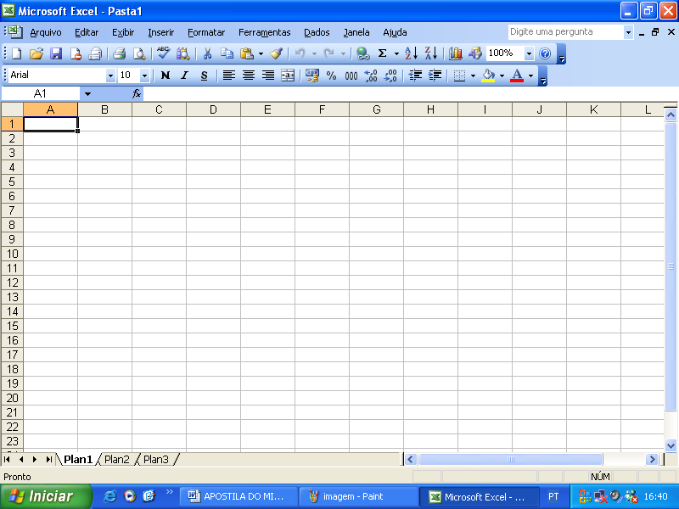
Barra de Menus
Barra de Título
Barra Padrão
Barra de Formatação
Barra de Fórmulas
Barra de Status

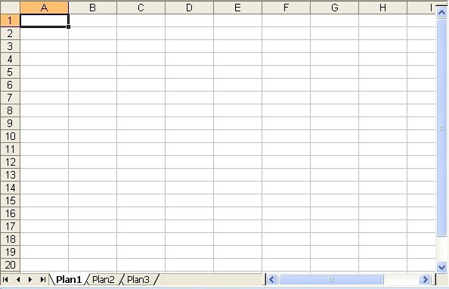
 BARRA DE FÓRMULAS

Mostra a célula selecionada pelo cursor, bem como a fórmula, função e ainda textos, se usados, em cada célula.

 ÁREA DE TRABALHO

É o local onde iremos digitar nas células e trabalhar com colunas e linhas de uma planilha.

OS COMPONETES DO EXCEL

Este software é composto de cinco partes fundamentais, que são:
Pasta ➔ É denominada “PASTA” todo arquivo que for criado neste software “Excel”. Tudo que for criado e posteriormente será um arquivo, porém considerado uma PASTA.
Planilha ➔ Uma planilha é considerada a parte onde será executado todo o trabalho por isso esta é fundamental. OBS: Dentro de uma planilha estão contidas as colunas, linhas e células.
Coluna ➔É o espaçamento entre dois traços na vertical. As colunas do Excel são representadas em letras de acordo coma a ordem alfabética crescente sendo que a ordem vai de A até IV, e tem no total de 256 colunas em cada planilha.
Linha ➔É o espaçamento entre dois traços na horizontal. As linhas de uma planilha são representadas em números, formam um total de 65.536 linhas e estão localizadas na parte vertical esquerda da planilha.
Célula ➔ As células são formadas através da intersecção “cruzamento” de uma coluna com uma linha e, cada célula tem um endereço “nome” que é mostrado na caixa de nomes que se encontra na Barra de Fórmulas. Multiplicando as colunas pelas linhas vamos obter o total de células que é 16.777.216.

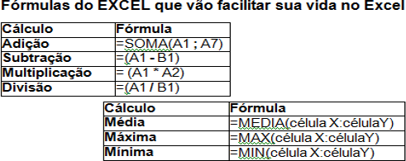
SINAIS OPERACIONAIS
Sinal de * = Multiplicação
Sinal de / = Divisão
Sinal de + = Adição
Sinal de – = Subtração
Sinal de ^ = Potenciação
Sinal de % = Porcentagem

Fórmula da soma - A fórmula irá somar todos os valores que se encontram no endereço. Os dois pontos indicam até, ou seja, some de A1 até A8. A fórmula será sempre a mesma, só mudará os devidos endereços dos valores que você deseja somar.
Fórmula da subtração - Numa subtração no Excel, você só precisa digitar o endereço dos devidos valores (inicial e final) acompanhado do sinal de subtração (-), como mostrar no exemplo abaixo. Para os demais funcionários você só bastaria copiar a fórmula.
Fórmula da multiplicação - Multiplica todos os números fornecidos como argumentos e retorna o produto. Agora a maneira como você subtraiu é a mesma para multiplicar, será preciso apenas trocar o sinal de subtração pelo o sinal de multiplicação (*). Ou: digitar a função:=MULT. (=MULT(A1*A2)
Fórmula da divisão - A fórmula ocorre da mesma maneira que as duas anteriores. Você só precisa trocar colocar o sinal para dividir (/).
Fórmula do máximo - Mostra o valor máximo de uma faixa de células.
Fórmula do mínimo - Mostra o valor mínimo de uma faixa de células.
Fórmula da média - Calcula-se a média de uma faixa de valores, após somados os valores e divididos pela quantidade dos mesmos.

EXERCÍCIOS DO MICROSOFT EXCEL

01 – Escreva Fórmula na planilha conforme o exemplo:

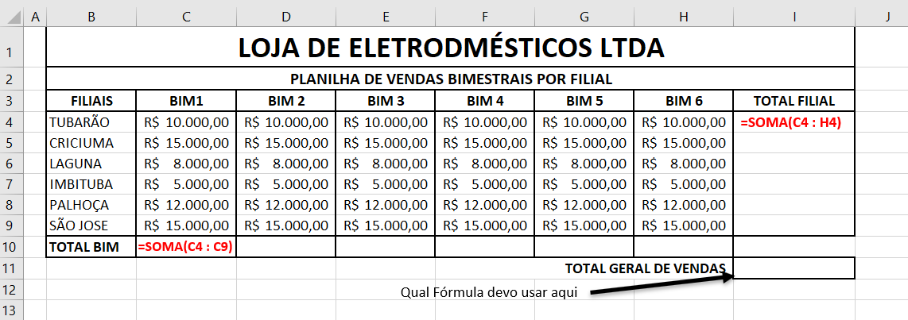

Boa Aula.

Grupo Escolar Municipal Monteiro Lobato
Coronel Martins, de de 2020.
Professor: Gilberto Bett
Disciplina: Informática Turma: 7º ano Aluno:

2ª SEMANA
EXERCÍCIOS DO MICROSOFT EXCEL

01 – Escreva as Fórmulas que pede em cada planilha e escreva ao lado:
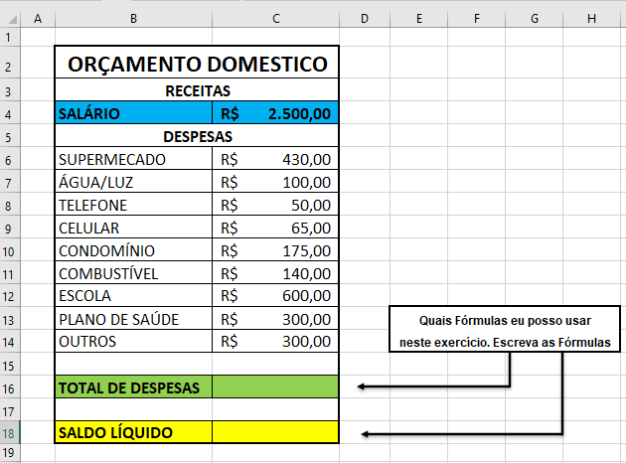

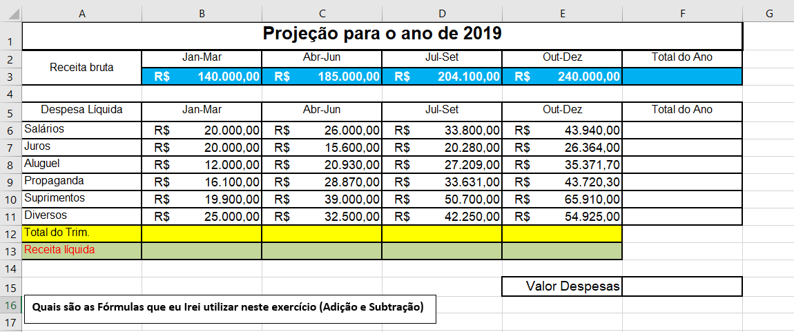

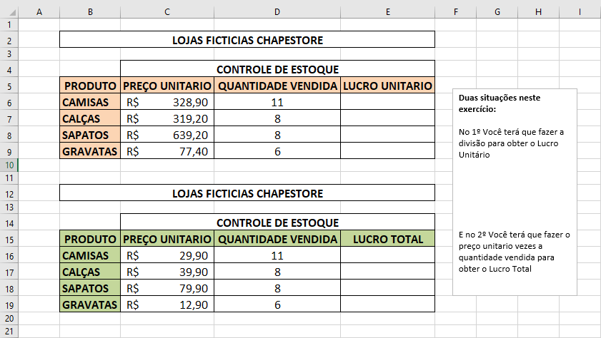

OBS:

Grupo Escolar Municipal Monteiro Lobato
Coronel Martins, de de 2020. Professor: Gilberto Bett
Disciplina: Ensino Religioso Escolar Turma: 7º ano Aluno:
1ª SEMANA



Nos últimos 200 anos, novos movimentos religiosos floresceram. Nunca houve tanta diversidade de correntes religiosas como agora. Em países que receberam múltiplas influências culturais, como o Brasil, sincretismos e crenças originais enriquecem a experiência da humanidade. O pluralismo religioso é uma característica marcante do País. Muitos segmentos têm sua fé marcada em tradições milenares entre outras religiões.
É sempre difícil respeitar o que não conhecemos. E, quando tratamos do complexo mundo das crenças, experimentamos dificuldades de compreensão, entendimento e respeito às religiosidades alheias. Daí a importância do diálogo, pois é ele que nos permite a troca, o conhecimento e o reconhecimento das vivências religiosas dos outros.
É muito comum conhecermos pessoas de diferentes religiões e, consequentemente, com tradições e hábitos diversificados. Respeitar essas diferenças é fundamental, principalmente porque o objetivo principal das religiões é transmitir os aspectos positivos dos seres humanos,

relacionados à sua natureza, princípios e valores, tendo sempre em mente a compreensão do outro.
Nos dias atuais, as religiões podem congregar-se pacificamente e reivindicar seus direitos, e, ao mesmo tempo, tornar pública essa diversidade desconhecida pela sociedade. Esse é um despertar de uma nova consciência tão necessária. Não podemos ficar apenas como meros espectadores diante do preconceito, do abuso, do fanatismo, das guerras em nome de religiões, exploração da fé de pessoas inocentes em nome de Deus, em Defesa da Liberdade Religiosa que se faz presente para que todos tomem consciência de fatos que antes ignorávamos.

ATIVIDADE:
01 – Faça um acrostico com as seguintes palavras:
D I V E R S I D A D E

R E L I G I O S A

Grupo Escolar Municipal Monteiro Lobato
Coronel Martins, de de 2020.
Professor: Gilberto Bett
Disciplina: Ensino Religioso Escolar Turma: 7º ano
Aluno:
2ª SEMANA

DECLARAÇÃO DO DIREITO À LIBERDADE RELIGIOSA DA ONU

A Organização das Nações Unidas (ONU) proclamou, em 1981, a Declaração sobre a eliminação de todas as formas de intolerância e discriminação fundadas em religião ou crença desta forma: "Toda pessoa tem direito à liberdade de pensamento, de consciência e de religião. Este direito inclui a liberdade de ter uma religião ou qualquer crença de sua escolha, assim como a liberdade de manifestar sua religião ou crença, individual ou coletivamente, tanto em público quanto em particular", diz o primeiro artigo da Declaração da ONU, para, mais adiante, advertir: "A discriminação entre seres humanos por motivos de religião ou crença constitui uma ofensa à dignidade humana (...) e deve ser condenada como uma violação dos Direitos Humanos e das liberdades fundamentais, proclamados na Declaração Universal dos Direitos Humanos."

ATIVIDADE:
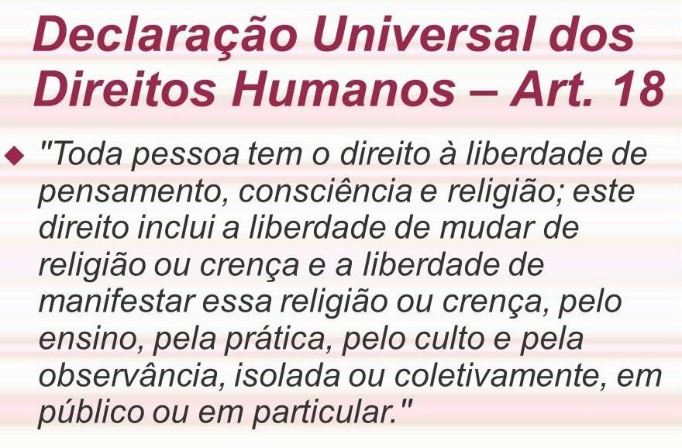
01 – A partir da imagem a seguir, coloque sua opinião ou crítica sobre o assunto:

GRUPO ESCOLAR MUNICIPAL MONTEIRO LOBATO.
ALUNO(a):....................................................................................................
DATA : atividades das semana de 20 abril a 01 de março de 2020.
Turma : 7º ano escola municipal
Disciplina : artes. AULA 01 E 02
“olá..... crianças estou com saudade de vocês ,mas devido ao que esta acontecendo , a pandemia do covid 19 teremos que trabalhar desta forma, portanto com a ajuda de seus pais e irmãos, por umas semanas trabalharemos assim, boa aula e usem bastante a criatividade, ok”
Atividades:
1)Ler atentamente e interpretar as pagina do livro (quem tiver melhor ,quem não tem lê nas fotos que mandei.) os conteúdos da 24 e 25:
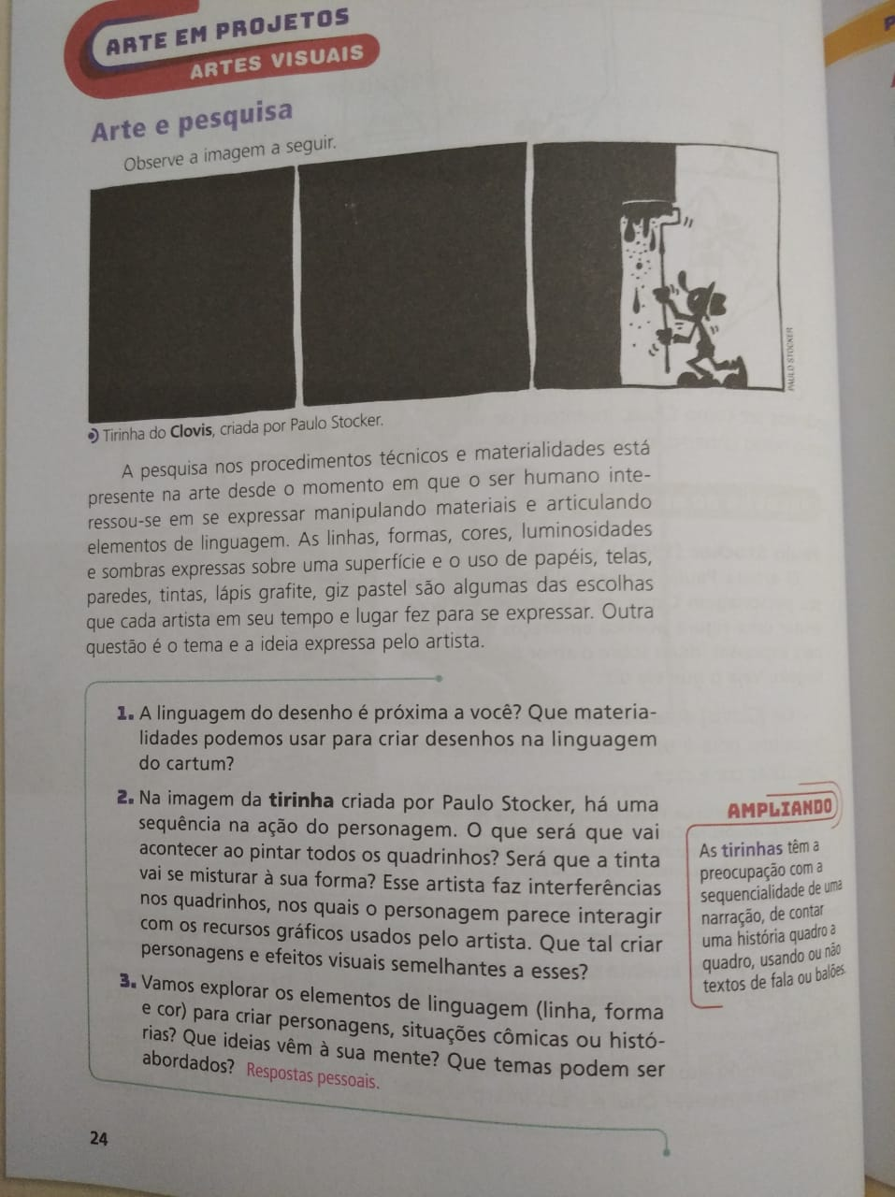
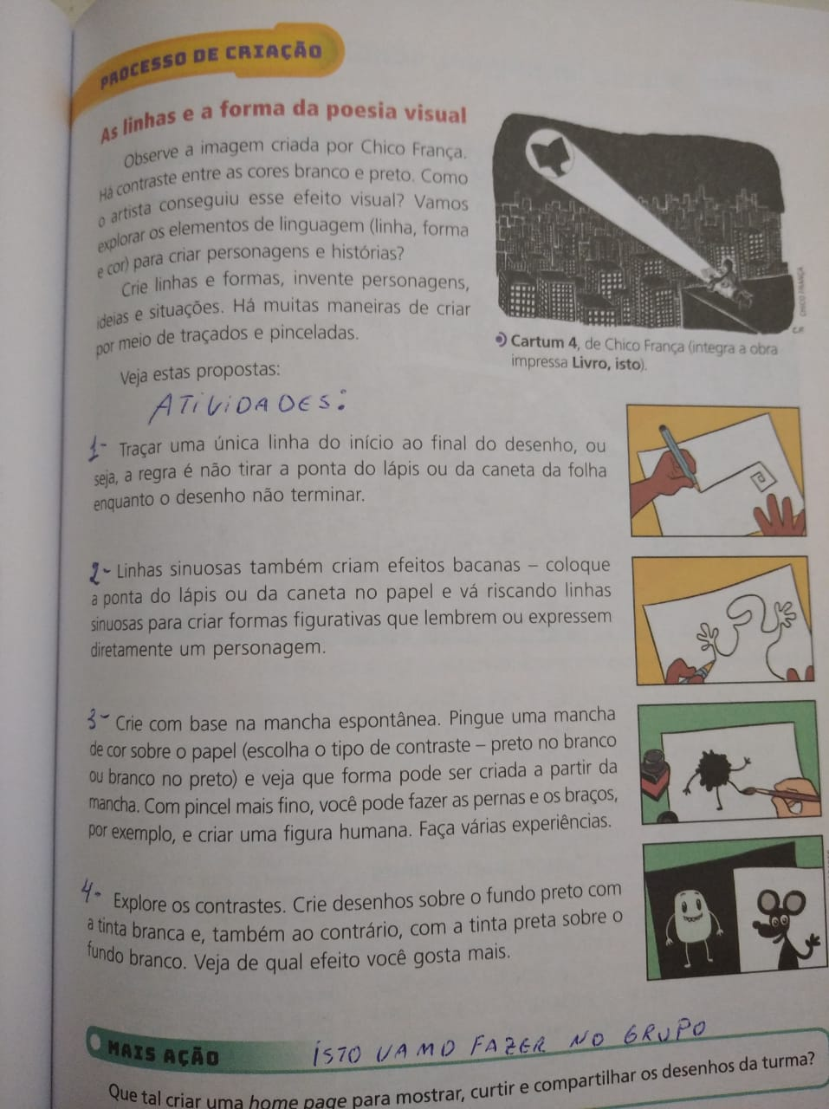
1 – desenho da atividade 1:

2 – desenho da atividade 2:
ALUNO(a):....................................................................................................
DATA : atividades das semana de 20 abril a 01 de março de 2020.
Turma : 7º ano escola municipal
Disciplina : artes. AULA 03 E 04
CONTINUAÇÃO DAS ATIVIDADES

3 - crie um personagem como o do livro explica bem colorido. Em um quadro de 10x10:

4 – seguindo o exemplo do livro trabalhe com fundo preto e fundo branco não use a tinta como o livro sugere use lápis de cor pra pintar os fundos em dois quadros 10x10 cm um com fundo preto e figura clara e outro com fundo branco e figura preta. Ok (se quiserem criar formas diferentes da do exemplo)

